RIHAM AHAMED ABDUL RAHEEM

HND COMPUTING IDM

Documentation

Contents

**USER DOCUMENTATION** 1

Basic Guidance 1

Type of Users 1

Registration Process 2

What is valid data? 2

The underlying process behind the database solution 3

**Consumer Process** 3

**Admin Process** 4

**WHAT IS DATA CORRUPTION?** 4

Making backups 4

Restoring backups 5

Emergency situation 5

**TECHNICAL DOCUMENTATION** 8

Data dictionary 8

**Data dictionary key** 8

Backup table 9

**IN-DEPTHS OF DATA CORRUPTION** 9

SQL Error 5172 9

SQL Fatal 823 Error 10

8946 SQL Server 10

**SYSTEM REQUIREMENTS** 11

**ADDITIONAL IMPROVEMENTS TO THE DATABASE SOLUTION** 11

References 12

**List of figure**

Figure 1: Registration Process 2

Figure 2: The underlying process 3

Figure 3: TMS Database data dictionary 8

# **USER DOCUMENTATION**

This part of the document describes most of the processes in the system in a way that is understandable without giving in technical terms. All general users who have a lack of IT knowledge or do not disclose application software should read this part of the document before using the solution.

## Basic Guidance

To extract the best from this database solution, you need to have a clear understanding of how this system works to fix it if needed. It is highly recommended that you refer to the documentation of the Microsoft SQL Server for further assistance if you encounter any inconvenience during use, as not every error that may occur while using this system can be covered. Use Google to help break down technical terms used in MS-SQL server documents.

## Type of Users

Users are categorized into 3 groups, depending on the role they have to play in extracting the best out of the system. Namely, Admins, Consumers and Supporters.

Admin users have read / write permissions, can change the passwords of consumers and other administrators, create consumer accounts, back up and restore the database, and completely erase all data in the database. Admin users are advised not to run the system too often. Administrators may have consumer accounts to participate in reading / writing activities. All IT staff are executives.

Consumer users have read / write permissions for all formats throughout the system. These users will actively and frequently operate the system by interacting with students, suppliers and other external visitors. All of the front office staff are consumers.

Support users will not interact with the system. They are there for the purpose of ensuring that the system works properly and to report management level or IT staff in case of sufficient error. So these users will not be displayed on most maps because they play an indirect role in the operation of the system

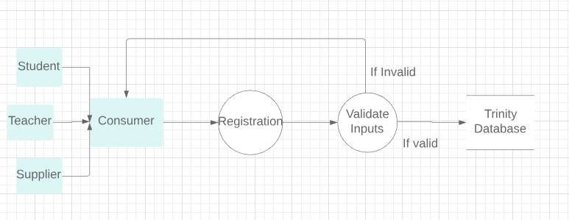Registration Process

Figure 1: Registration Process

During registration, a consumer receives data from a student, teacher, or consumer and begins to enter the information received into an entry form, which is marked on the map as "Registration" to begin the registration process. Data not accepted.

## What is valid data?

For each specific piece of data entered into the database, there is something called a "data type". A data type is a classification of data, for example a dog is a mammal, a man is a mammal, as well as an identification number (ID). Refer to the Data Dictionary in the Technical Documentation to find out what data type a particular data is.

## The underlying process behind the database solution

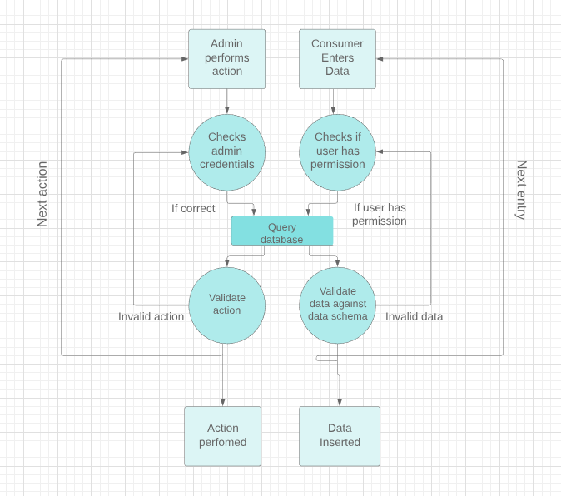

Figure 2: The underlying process

### **Consumer Process**

Only has read / write permissions on a consumer database. If the consumer tries to do something that the user cannot read or write to the database, the database will not allow that consumer to enter that data into the database. After the permit test is completed, the database is queried as to whether the database is "queried" or, in simple terms, the datasets of the entered data table. A data plan is a table that holds the data types of each data item. If they match, the data can be inserted and the next entry can be made, otherwise the question or "query" will be rejected.

### **Admin Process**

An administrator is more capable than reading or writing. They can delete data, create backups, and restore them. So, to do this you need to see if the administrator username and password are correct and if they query the database, see if they can do that. If that action can be performed it will be performed, then the next action can be performed or if it is not performed the action will be discarded.

# **WHAT IS DATA CORRUPTION?**

SQL Server is a platform used for business stability. However, like other databases, it is prone to corruption. It is the damage or destruction of data due to some kind of external factor.

There are 3 common errors that result from data corruption:

1. SQL Error 5172
2. SQL Risk 823 Error
3. 8946 SQL Server

The only solution in such a situation is to restore the previously stored backup because it is important to create such backups. See **Data Corruption In-Depth** for more details on these errors and how to fix them. (techopedia, 2021)

## Making backups

The following are the steps to take to create a full backup of the database TMS.

* In Object Explorer, add an event from the SQL Server Database Engine and expand that event.
* Expand the database, right-click on TMS, point to tasks, and then click Backup.
* On the General page in the Section Target section, select Disk from the back: Drop-down list.
* Existing Click Remove until all existing backup files have been removed.
* Clicking Add will open the Backup Destination dialog box.
* The Go to the location where you want to save the backup, then add the .bak file name in the text box.
* Click OK.
* Click OK.

See the backup Schedule to find out when and how often you need to create backups.

## Restoring backups

The steps to take to restore the full backup of the database TMS are as follows.

* In Object Explorer, add an event from the SQL Server Database Engine and expand that event.
* Right-click the database and select Reset Database.
* On the General page, select the device under the Source section.
* Select Backup Devices Click the Browse button to open the dialog box. Click Add and go to your backup. After selecting your disk backup file, click OK.
* Click OK to return to the public page.
* Click on the Page Select option.
* Under the Restore Options section, overwrite the existing database (with modification).
* Click OK

## Emergency situation

If for some reason the database is lost, there are no backups or recovery procedures do not work, then follow these steps to run the following queries

* After opening the SQL Server Management Studio, go to the 2nd menu-bar and click New Query.
* Copy and paste the set of queries mentioned below.
* Highlight the 1st line of the line and click Execute in the 3rd menu bar.
* Then highlight the rest and click Run.

After following this process, a new and blank database called TMS will be created with all the tables. Simply create the database solution again.

CREATE DATABASE TMS;

USE DATABASE TMS;

CREATE TABLE Student

(

StudentID int PRIMARY KEY,

Name varchar(100) NOT NULL,

Type varchar(100) NOT NULL,

DOB date NOT NULL,

Register_Date date NOT NULL,

Contact_Number int,

ClassID int FOREIGN KEY REFERENCES Class(ClassID),

);

CREATE TABLE Class

(

ClassID int PRIMARY KEY,

Start_Date date NOT NULL,

End_Date date NOT NULL,

Fees money NOT NULL,

StudentID int FOREIGN KEY REFERENCES Student(StudentID),

TeacherID int FOREIGN KEY REFERENCES Teacher(TeacherID),

InstrumentID int FOREIGN KEY REFERENCES Student(InstrumentID)

);

CREATE TABLE Teacher

(

TeacherID int PRIMARY KEY,

Name varchar(100) NOT NULL,

Contact_Number int,

ClassID int FOREIGN KEY REFERENCES Class(ClassID)

);

CREATE TABLE Instrument

(

InstrumentID int PRIMARY KEY,

Name varchar (100) NOT NULL,

Quantity int NOT NULL,

Rental_Price money NOT NULL,

ClassID int FOREIGN KEY REFERENCES Class(ClassID),

SupplierID int FOREIGN KEY REFERENCES Supplier(SupplierID),

);

CREATE TABLE Supplier

(

SupplierID int PRIMARY KEY,

Name varchar (100) NOT NULL,

Address varchar(150) NOT NULL,

Contact_Number int,

Instrument int FOREIGN KEY

REFERENCES Instrument(InstrumentID)

)

# **TECHNICAL DOCUMENTATION**

## Data dictionary

The data dictionary contains all the necessary information, including data types, examples, and the location of each field in the database. Database dictionary can be very useful when adjusting, because before using the database solution, check the following in full.

### **Data dictionary key**

* **Table Name**: The name of the table.
* **Field Name**: The name of the column in a table.
* **Data Type**: The type of data listed in the table's data plan.
* **Data format**: General syntax of the field name.
* **Field size**: Maximum character limit for field name.
* 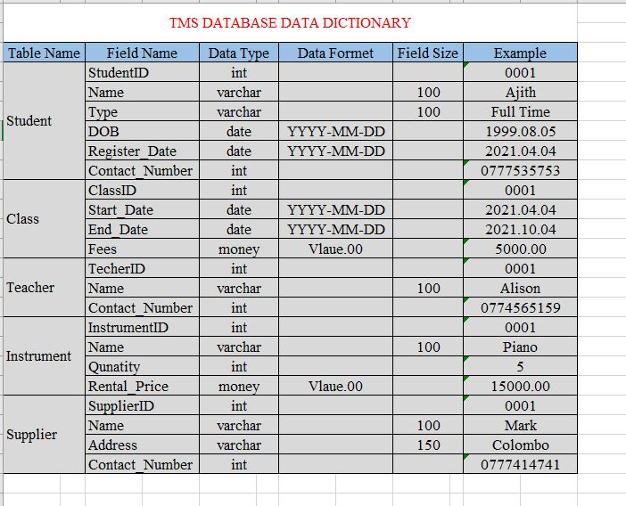**Example**: Possible data to meet the data plan and other constraints

Figure 3: TMS Database data dictionary

## Backup table

Administrators are responsible for backing up the database TMS following the steps outlined in the user document, subject to the following conditions:

1. By default, backup of the database should be done once a week and then stored on the external device.
2. Back up and compress once every year, then make a flush with the database on January 1 each year at 00:00.
3. Backup immediately if available:

* The data plan of any table can be edited in any way.
* Table X Dropped.
* Table X Add.
* Cleaning Data cleaning procedures have been done.
* Data Further data is normalized.
* Significant amounts of sensitivity or valuable data are inserted into one of the set tables.

# **IN-DEPTHS OF DATA CORRUPTION**

## SQL Error 5172

The SQL server stores its physical database in a primary file containing pages of data. The first page contains information on the title of the MDF file, which is called the title page.

It contains various information about the database such as file size and signature. The most common error users encounter during the process of attaching MDF to the SQL Server is 5172.

This usually happens when the MDF file is unhealthy or damaged. Once this error occurs, the information in the title file already does not match, making it difficult to access the data.

This error is usually caused by:

* 1. Poor shutdown of the server system.
  2. Attacks from a malicious virus.
  3. Incorrect shutdown of SQL Server.
  4. Server hardware malfunction.

Recovering from this error can only be done by a database administrator or a computer administrator who specializes in the field of data. If you are unable to find experts who are capable of troubleshooting this error, restore the backup on a clean installation of the Microsoft SQL Server as documented here. (Admin, 2019)

## SQL Fatal 823 Error

SQL users use Windows APIs to enable I/O functions. Once the I/O operations are complete, SQL checks for any errors associated with API calls. If these API calls do not match the operating system, error 823 occurs on the SQL server.

This error message contains the following information:

1. The I/O function is a write or read request
2. Offset in the file where the I/O function tried
3. I/O function enabled file
4. System operating system error code and error description

Error 823 Message indicates that there is a problem with the basic storage machine hardware or a driver that is in the path of I / O request.

When users encounter this error:

* There are conflicts in the system file system.
* File If the database file is corrupted.

The only way to recover from this type of error is to use compatible MS. Go to the machine on which Windows is installed and match the system requirements for the solution to run

## 8946 SQL Server

The main reason behind error 8946 is corruption in the SQL database. Once the error occurs, it is difficult to access the files.

Also, it can occur when a specific assigned page does not have the correct page title. There are various reasons for the error. Some of these include power outages, virus infections, abrupt engine shutdowns, and hardware failure.

When captions are corrupted or damaged, the entire data is corrupted, which can lead to data loss. To avoid this, it is important to fix this problem as soon as possible. To fix this, contact a database administrator or developer.

# **SYSTEM REQUIREMENTS**

* 1.8 GHz or faster x86 (Intel, AMD) processor. Dual-core or better recommended
* 2 GB of RAM; 4 GB of RAM recommended (2.5 GB minimum if running on a virtual machine)
* Hard disk space: Minimum of 2 GB up to 10 GB of available space

# **ADDITIONAL IMPROVEMENTS TO THE DATABASE SOLUTION**

If Trinity Music School makes any improvements to the existing installation at any time, show the following list to the contractor:

1. Deploy the database to a centralized cloud database server and enable SSH to connect to the server. You can use the bottle if personal activation is out of range.
2. Enable encrypted bit streams between users and host systems using standard encryption algorithms, such as the American Encryption Standard, in the 256-bit variant of GCM mode.
3. Provide instructions to Trinity Music School to make encrypted backups or create a system to automate the backup process, but instead create encrypted backups.
4. Stay away from an SQL RDBMS such as MSSQL and use a NoSQL installation such as MongoDB, as the data program and environment are not yet mature for SQL, thus reducing flexibility during data storage.
5. Use automated scheduling and work on SSMS to automate backups and clean up authentication data.
6. Introduce an MDF viewer to TMS so that they can view their table without running SQL commands.
7. If the database is used for a centralized cloud, proceed to create a RESTful API to communicate with the database via the load balance layer, such as NGNX and an encryption monitor.
8. Introduce Trinity Music School to SAP Crystal Reports to better display data for easy management decisions.

# References

Admin, 2019. *FREEVIEWER.* [Online]   
Available at: https://www.freeviewer.org/blog/fix-sql-server-header-error-5172/#:~:text=Download%20Purchase%20Now-,Microsoft%20SQL%20Server%20Error%205172%20%E2%80%93%20The%20File%20Size%20Property%20Is,contains%20the%20data%20by%20pages.&text=It%20occurs%20when%20the%  
[Accessed 09 04 2021].

techopedia, 2021. *Data Corruption.* [Online]   
Available at: https://www.techopedia.com/definition/14680/data-corruption  
[Accessed 09 04 2021].